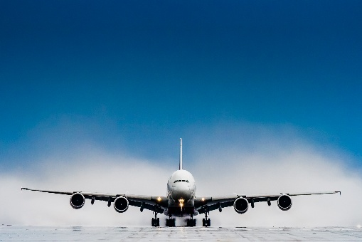

Travel Insurance Considerations
Travel insurance is not included as part of a safari trip. Many companies offer trip insurance. No matter which company a person chooses for their South Africa photography safari, it is an investment. Travel insurance that covers flights, lost luggage, delayed flights, unexpected illness, and evacuation insurance are the personal decision of participants. Over the past years, we have found that 50% of our participants have chosen to purchase trip insurance. While travel insurance—covering flights, lost baggage, delays, unexpected illness, and emergency evacuation—is ultimately a personal choice, it is highly recommended.
To put the risk into perspective, in our 16 years of operation, we have only experienced one instance where an airline canceled a flight to Johannesburg, causing participants to lose two days of their safari. In that specific case, flight insurance would have fully covered their lost days and flight costs.
Normally, trip insurance is purchased the day a person books their flight. Many airlines offer flight insurance, and some offer entire trip insurance. Most of our trips are booked through Delta airlines, but participants may choose other carriers. Please investigate what level of insurance you feel you will need. Be sure to check out your local insurers. The following recommendations are offered to get you started, as you investigate trip insurance.

Whole trip insurance
Travel Guard Insurance - A+ rating – Http://www.travelguard.com
Allianz - https://www.allianztravelinsurance.com
Faye - https://www.withfaye.com
World Nomads - https://www.worldnomads.com/usa/travel-insurance

Flight Insurance
Typically flight insurance covers the entire cost of lost flights, lost luggage, and unexpected cancelation due to illness or family circumstances. Most airlines offer such insurance, and it is purchased when you make your flight arrangements. Delta airline trip insurance is highly recommended.
Evacuation insurance
Evacuation insurance covers unexpected events such as stroke, heart attack, personal injury, or severe illness that requires an immediate return to your country of origin. We recommend that you contact AJ at Global Rescue as the contact person. His email is ajfernandez@globalrescue.com. Be sure to tell AJ that you are a participant in a safari co-sponsored by Kolobe Safaris.

